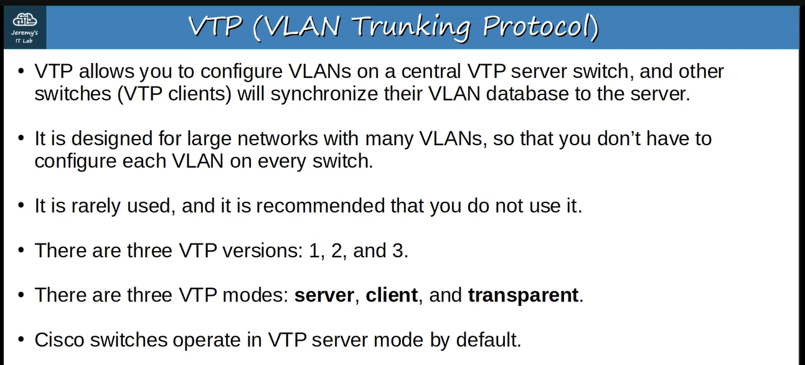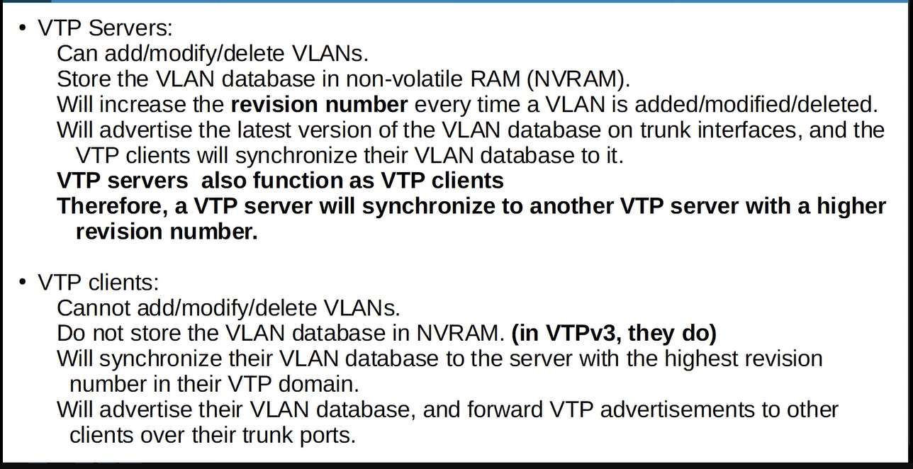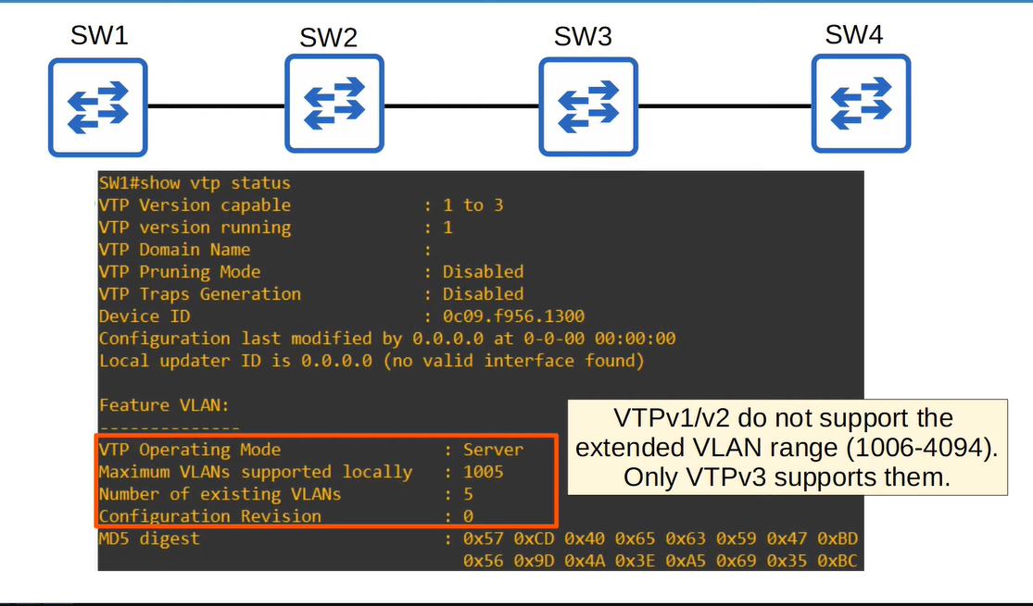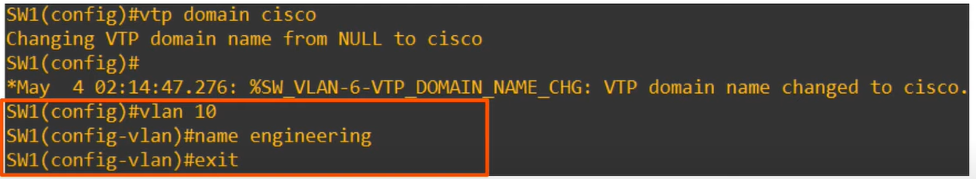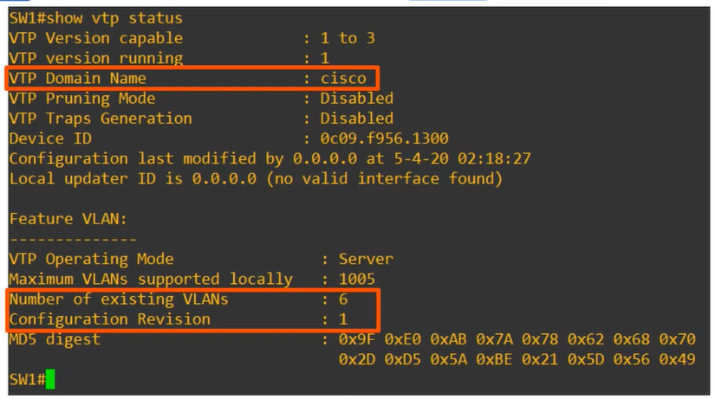

**Remember other switches will change their domain name and configuration revision and also VLAN name, because ↓ 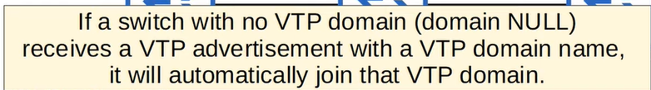 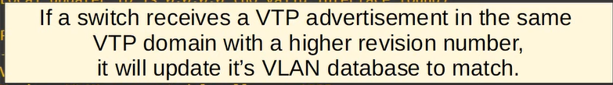 therefore ↓** 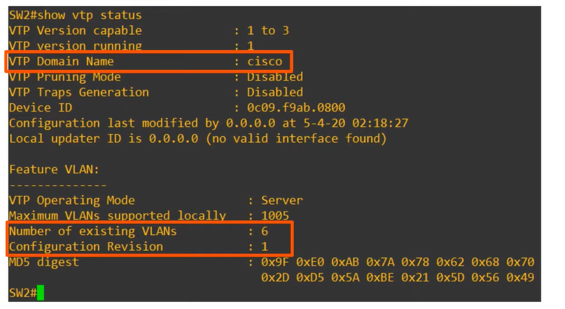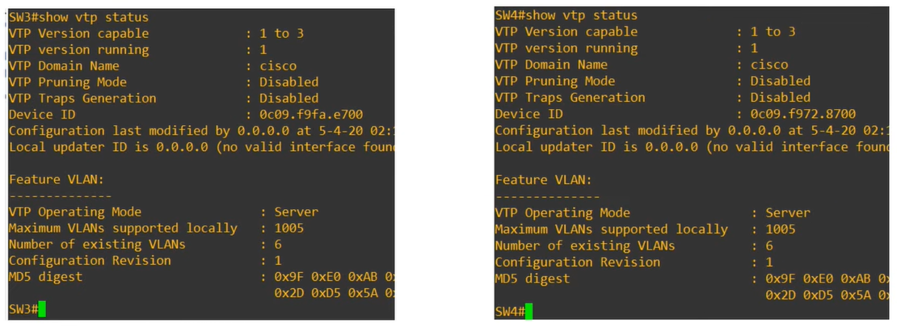

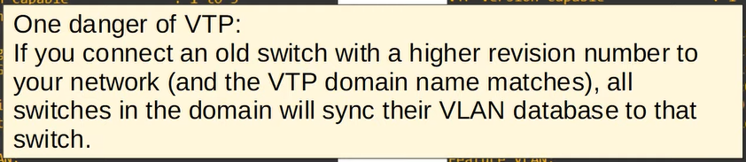

**e.g., ↓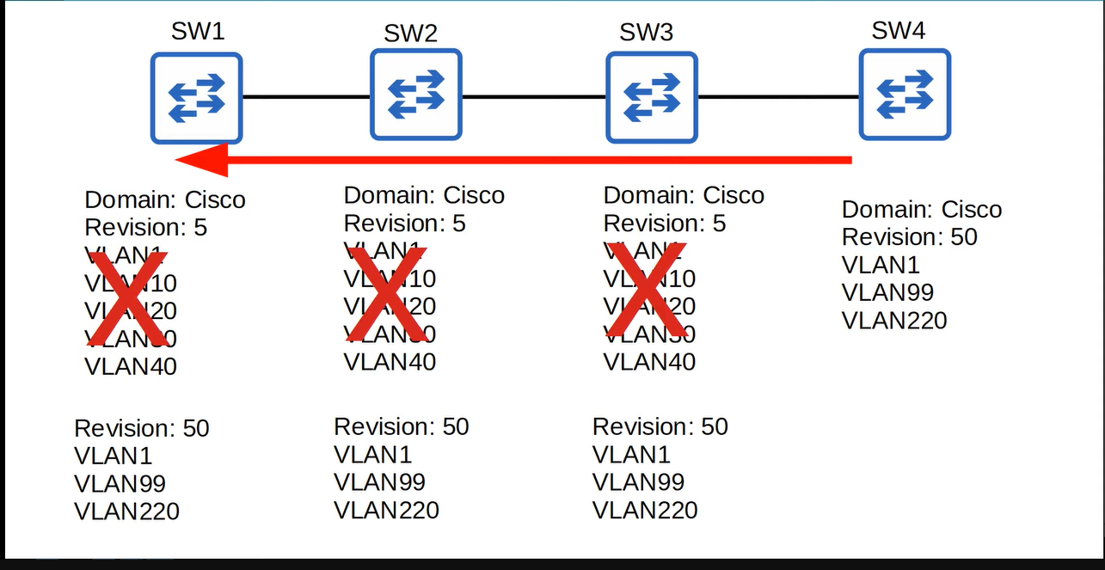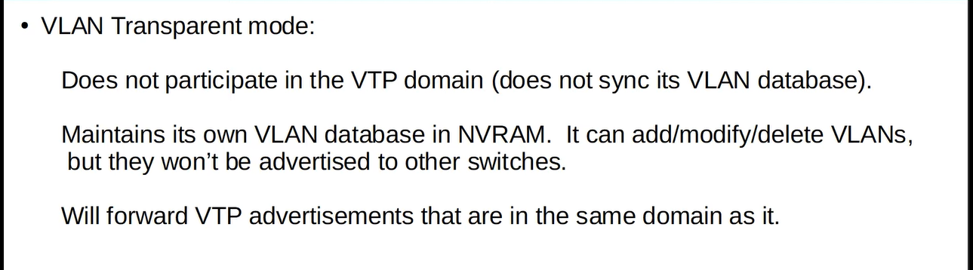e.g., ↓** 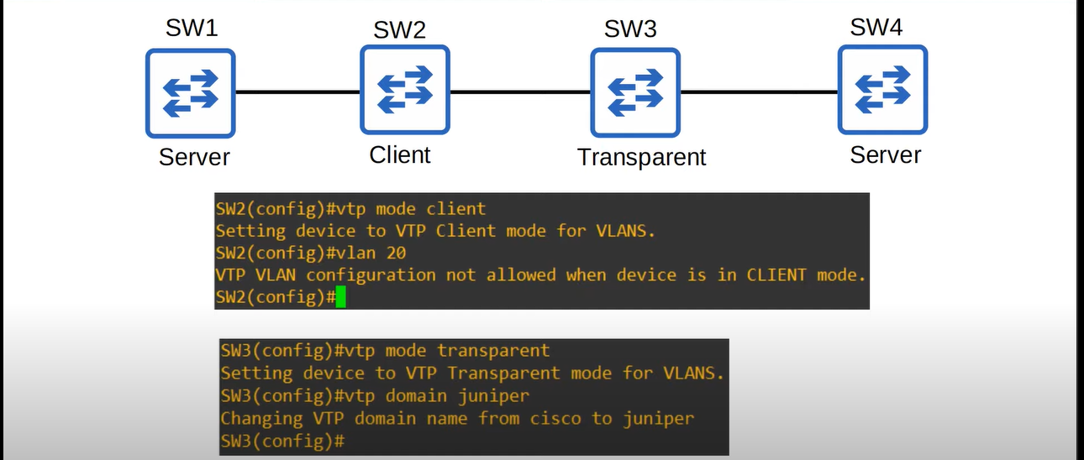

**if we create a VLAN named “Sales” on SW1 then it will also be automatically created on SW2 but not on the SW3 because it is in transparent mode and not on the SW4 because the SW3 does not advertise to other switches and it will also happen with configuration ↓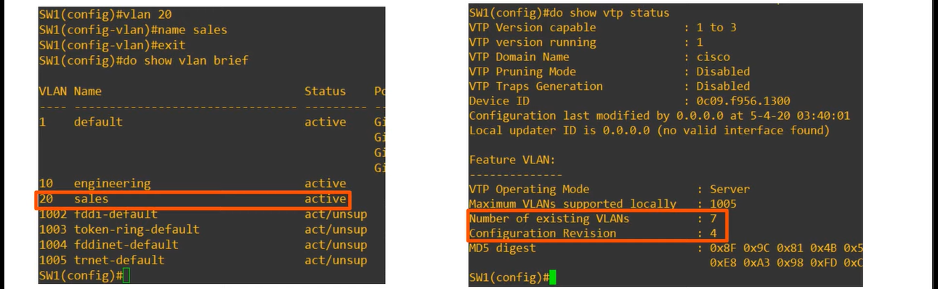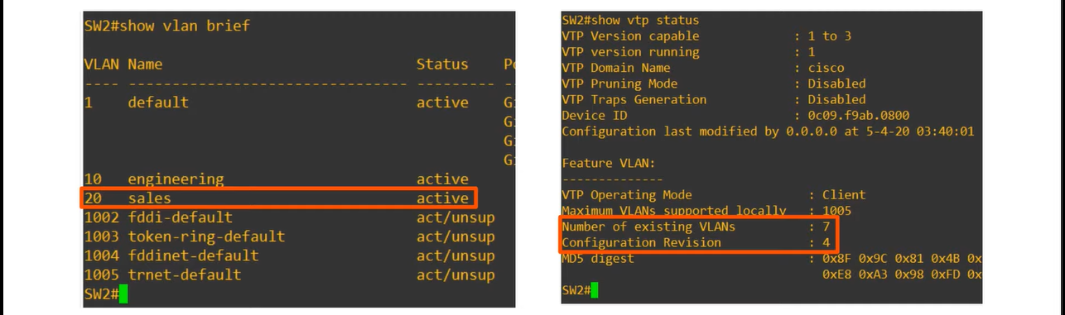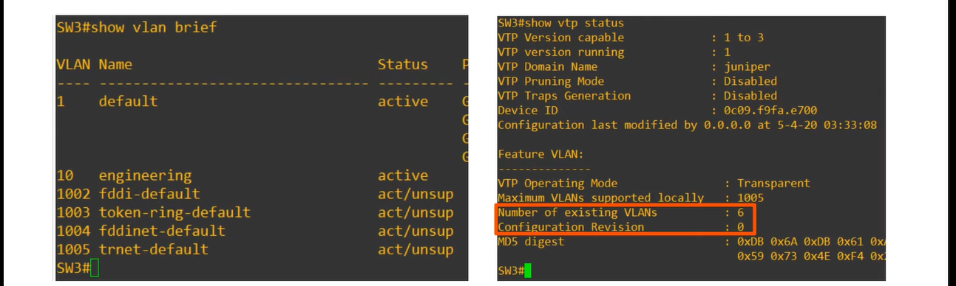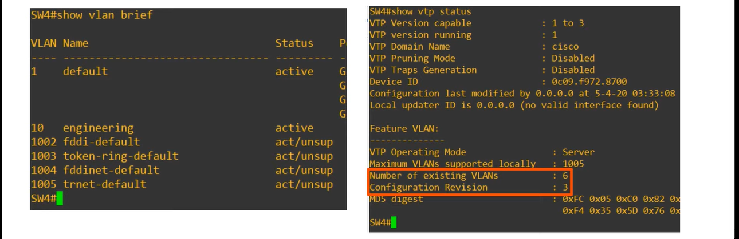Remember ↓**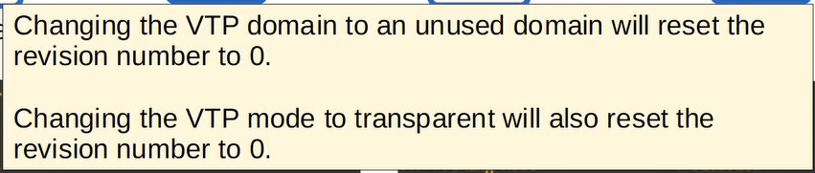

**if we change the VTP domain on SW3 back to “cisco” because other switches have this name, it will start forwarding advertisements to SW4, but SW3 will not changing on itself due the forwarding the advertisements, e.g., on changing the version on SW1, version of SW4 will also be changed ↓**